**Bridging the Gap (Manchester) (BTG)** 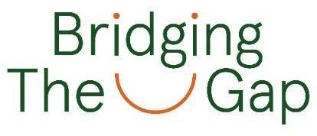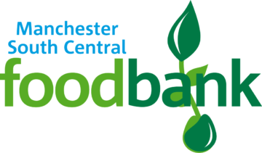

**operating as Manchester South Central Foodbank (MSCF)**

**Data Privacy Statement for Donors**

**Personal data**

When donors provide food donations or gifts in kind to Bridging the Gap (BTG) we will keep some data about you. This includes some ‘personal data’, because it is identifiable information about you as an individual person

**What personal data does Bridging the Gap hold?**

BTG will keep data about its donors on an on-line data system. This will record your name or the name of your group, telephone number, email address and postal address. This is the only data BTG will usually hold about you. There may also be information about you in emails but this information will be kept no longer than needed.

**How is your personal data kept safe?**

Your data is kept in a secure on-line database. This can only be accessed with a log-in and password. BTG requires all users of its system to sign a ‘data protection statement’. This means they know they must keep your data safe, and only use it for the right purposes. All our volunteers also have to sign a confidentiality agreement. BTG is as careful as possible to make sure no unauthorised person can log into its data system. For example, when an admin volunteer, member of staff or a trustee leaves the foodbank, BTG stops their access to the data system.

**What is your data used for?**

Your data will only be used to contact you about food or financial donations. For example, this could be to advise you of shortages of certain items, to thank you for your donation, or to prompt you about delivery arrangements for harvest or Christmas donations. BTG may also use your data to send you newsletters or information about its work. BTG has a separate ‘Data Privacy Statement for Supporters’. Please ask if you would like to see a copy of this particular data privacy statement.

**Does the foodbank have a right to your data?**

Under Data Protection legislation, BTG needs to have a ‘lawful basis’ for keeping your data, and for using it. There are several types of ‘lawful basis’. One of them is called ‘performance of a contract’.

When you become a donor, we enter into a ‘contract’ or relationship together. You undertake to make food donations to the foodbank; we undertake to give you information about the work BTG does and about the difference your donation makes. To do this, BTG needs to hold data about you. That is why the lawful basis for holding your data is the ‘performance of a contract’.

If BTG sends any of its donors information about its work, the lawful basis for this is ‘legitimate interest’. As a supporter group, BTG believes that it is reasonable (that is, legitimate) for it to keep you informed. Communications about its work will always have an opt-out or ‘unsubscribe’ option.

**Who can see your data?**

Your data on BTG’s on-line system can only be seen by authorised people who have been given a log-in and password for our data system. BTG is as careful as possible to make sure no one else has access to your data.

**How long will your data be kept?**

Your details will be kept for as long as you are happy to be a donor. You can stop being a donor at any time, BTG will delete your/your organisation’s data from the on-line system’s record of active donors. The data system will still record donation amounts and dates, but your contact details will not be kept.

**Who can you speak to if you have questions?**

If you have questions about your data, and what we do with it, you should contact BTG’s Data Protection Officer at [jennifer@manchestersouthcentral.foodbank.org.uk](mailto:jennifer@manchestersouthcentral.foodbank.org.uk)

**What rights do you have?**

You have a number of rights under Data Protection legislation: -

1. Right to know what data we hold  
   You have a right to know what personal data BTG holds about you. This Data Privacy Statement describes the data that we will hold. But you can ask if we have any other data about you, which is not covered by this Data Privacy Statement.
2. Right to have a copy of the data we hold  
   You can ask for a copy of the data BTG holds about you. This is called a ‘subject access request’.

If you make a subject access request, BTG will give you a copy of all the data held about you within one month of your request. If it helps, you can be provided with the data in a computer file format.

1. Right to object  
   You can object if you think BTG is using your data in the wrong way. You can also object if you think we don’t have ‘lawful grounds’ for using your data. We will give you a statement explaining why we use your data and explaining the ‘lawful grounds’.

If you are still not happy, you can complain to the Information Commissioner’s Office. If BTG finds it is using your data in the wrong way, we will stop immediately and stop it from happening again.

1. Right to have your data corrected  
   If you think there is a mistake in your data, please tell us. You have a right to have it corrected. BTG may first need to check what is the correct data, but will correct any mistakes as soon as possible.
2. Right to be forgotten  
   BTG promises to remove your data after six years. You have a right for this to happen, because we don’t generally need to keep your data any longer than six years.

Finally, if anything happened to your data that could be a risk to you, BTG will do its best to tell you as soon as practicable possible.

**Privacy statement reviewed & updated: 16th September 2024**

**Next review due: 16th September 2025**