Job description

Job title: Foodbank Project Manager

Location: Bridging the Gap (Manchester), Unit 3, Wesley Enterprise Centre,
Old York Street, Hulme, Manchester, M15 5BP

Contract: Fixed term for 12 months, with possible extension subject to funding

Responsible to:
The Project Manager will be employed by Bridging the Gap (Manchester) Trustees,
and will be supervised and managed by an appointed Trustee

Purpose and objectives:
To manage Manchester South Central Foodbank, a project based in the Manchester Borough of Hulme, and operating within the Hulme, Moss Side, Whalley Range and Old Trafford Wards. Manchester South Central is affiliated to the Trussell Trust network but can independently make its own operational decisions.

Main responsibilities:
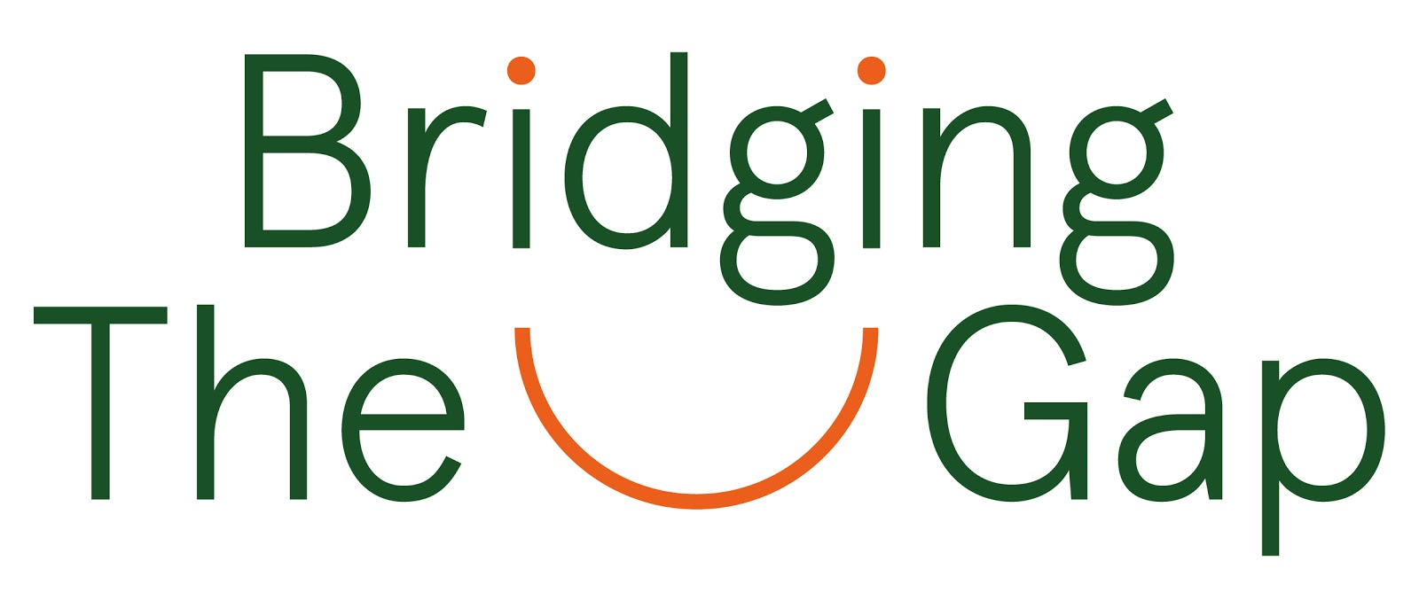
To manage the foodbank and its food related services, including working towards the “time for change” agenda and the development of More than Food projects, working with identified staff members and volunteers in cooperation with Trustees.

- To ensure the ongoing work of the project through liaising with:

      - Referral agencies
      - Donors including members of the public and corporate sponsors
      - Statutory and voluntary agencies
      - Foodbank projects in other areas including Trussell Trust foodbanks and independent food providers
      - Our Manchester Food Partnerships and associated task force groups

2. Secure funding for the project and the post

3. Overseeing the day to day management of the Foodbank processes, including

      - Creating, planning, and organising initiatives, activities and events as agreed with the Board of Trustees.
      - Supporting warehouse staff members and volunteers
      - Distribution centres
      - Administrative task which include updating data collection systems
      - Managing budgets and preparing both financial and project reports
      - Partnerships

4. Line manage and train volunteers to support best delivery of the Charities projects.

5. Develop the project by:

      - Carrying out public relations activities to raise the profile of Bridging the Gap, its Foodbank services and More Than Food Projects.
      - Maintaining and nurturing relationships with agencies and organisations, Foodbank distribution sites, community networks and corporate partners
      - Exploring potential developmental opportunities
      - Working in partnership with Hulme Partnership Network and Our Manchester Food Partnership
      - Exploring funding opportunities

6. Ensure regular monitoring and reports are submitted to the Trustees in a timely
manner

7. To ensure that Bridging the Gap (Manchester) policies and procedures, such as Health
and Safety, Safeguarding, Data Protection and risk assessments are observed at all
times

8. Any other duties which may reasonably be regarded as within the nature of the post,
subject to the proviso that normally any changes of a permanent nature shall be
incorporated into the job description in specific terms.

Person Specification:
To join us as a Foodbank Project Manager, you will be required to have the following skills

Essential Skills:
- Knowledge and understanding of various sectors, including Statutory, voluntary and not-for-profit,
- Experience of project management, including people management
- Experience of community development work from an asset based approach
- Experience of managing budgets and of financial reporting
- Excellent time management skills and self discipline
- Experience of maintaining relationships with members of the public, partner agencies, corporate sponsors and the media.
- Knowledge and understanding of the principles of Safeguarding in relation to working with vulnerable adults, children/young people and volunteers
- The ability to work under pressure and respond creatively to challenges

Desirable Skills:
- The ability to effectively manage, evaluate and monitor the development of a project
- Empathy and an understanding of the challenges of supporting individuals in crisis and of managing volunteers
- The ability to lead, motivate, and support staff members
- The ability to lead, motivate, train and support volunteers
- Good communication and interpersonal skills
- Good computer skills including regular use of email, internet, word processing and spreadsheets in order to undertake administrative tasks
- Knowledge of and a commitment to adhere to and promote the values and ethos of Bridging the Gap (Manchester)
- Creativity and flexibility to meet the demands of a developing Charity

Terms and Conditions

Normal working hours:
25 hours per week as agreed. This includes some agreed fixed core hours based in the office; other hours to be flexible including the possibility of some weekend and evening hours.

Salary:
£31,200 per annum pro rata (£19,500 actual salary)

Annual leave:
5.6 weeks (including 8 days public holidays) pro rata

Expenses:
All reasonable expenses will be reimbursed but must be prior authorised by a Trustee.

Appointment:
Successful candidate will be subject to a satisfactory enhanced DBS disclosure and references.

Appointment will be subject to the satisfactory completion of a probationary period, initially of 3 months. Notice period of 1 week during probation rising to 4 weeks after the probationary period.

Start date: To be confirmed but no later than 1 April 2022

How to apply
Applications to be submitted via email, including a CV and covering letter, highlighting your strengths, skills, experience and motivation for the job. Covering letter should be no more than two sides of A4. Documents to be emailed to; recruitment@manchestersouthcentral.foodbank.org.uk
Applications close at midday on Friday 4 February 2022, with interviews likely to take place week beginning 21st February.

