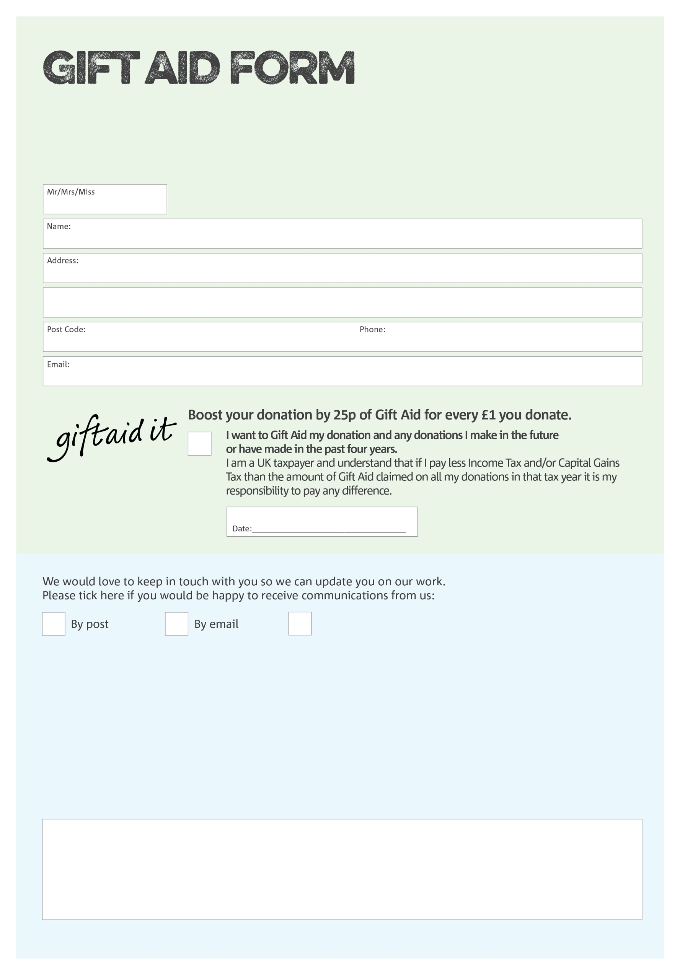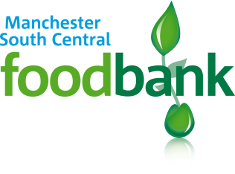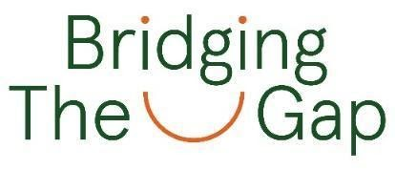

By filling in this form Bridging the Gap (Manchester) who operates Manchester

South Central Foodbank will receive an extra 25p for every £1 you give at no extra cost to you. Thank you!

Mr/Mrs/ Ms/ other:

Address:

Name:

Phone:

You can change your preferences any time by contacting us on 0161 226 3413 or emailing us at [finance@manchestersouthcentral.foodbank.org.uk](mailto:finance@manchestersouthcentral.foodbank.org.uk)

xxxxxx@xxxxxx.foodbank.org.uk

I do not wish to receive future communications from Manchester South Central Foodbank

We would love to know why you have chosen to donate to Manchester South Central Foodbank. If you would like to share your motivation let us know below:

**Data protection**

*'Manchester South Central Foodbank is committed to protecting your privacy and will process your personal data in accordance with current Data Protection legislation. Manchester South Central Foodbank collects information to keep in touch with you and supply you with information relating to our work. To unsubscribe from our newsletter, send a message to the email address above with the word unsubscribe in the subject line. A full data privacy statement for financial donors is available from the foodbank on request.’*

Date:

Email:

Postcode:

Charity Number 1170952. Registered in England and Wales