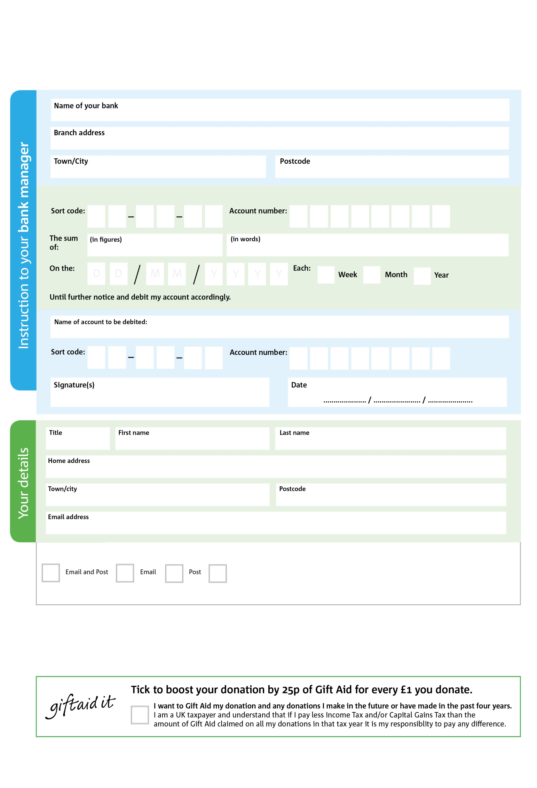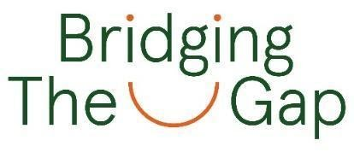

Postcode:

Email:

Postcode:

Town/ city:

Address:

Last name:

First name:

Title:

Date:

Signature:

Name of account to be debited:



(In words)

(in figures)

**Bridging the Gap (Manchester) is the registered Charity who operates Manchester South Central Foodbank. Please pass this form onto the foodbank, using the foodbank’s address at the bottom, who will save a copy for their records. They will then send it onto your named bank or building society.**

Town/ city:

Branch address:

Name of your bank:

Reg. Charity No: 1170952 | Reg. in England & Wales

6

V

6

V

0

V

6

V

5

V

9

V

0

V

2

V

5

5

4

0

We would love to keep you up to date with information about Manchester South Central Foodbank. Please tick your preference:

You can change your preferences any time by contacting us on 0161 226 3413 or emailing us at finance@manchestersouthcentral.foodbank.org.uk

I do not wish to receive future communications from Manchester South Central Foodbank

**Data protection**

*'Manchester South Central Foodbank is committed to protecting your privacy and will process your personal data in accordance with current Data Protection legislation. Manchester South Central Foodbank collects information to keep in touch with you and supply you with information relating to our work. To unsubscribe from our newsletter, send a message to the email address above with the word unsubscribe in the subject line. A full data privacy statement for financial donors is available from the foodbank on request.’*

You can change your preferences any time by contacting us on XXXXXXXXXXX or emailing us at XXXX@XXXXXXXXXX.foodbank.org.uk

I do not wish to receive future communications from XXXXXX Foodbank

POSTAL ADDRESS: Manchester South Central Foodbank, Unit 3, Wesley Enterprise Centre, Royce Road, Hulme, Manchester, M15 5BP

2

5

4 X

Please pay. Bridging the Gap (Manchester) Manchester South Central Foodbank Foodbank,

**Standing Order Mandate**

**xxxxxx.foodbank.org.uk**